assessment instrument

**APPLY PRINCIPLES OF CREATING COMPUTER SOFTWARE BY DEVELOPING A COMPLETE PROGRAMME TO MEET GIVEN BUSINESS SPECIFICATIONS**

**US ID:** 115392

**NQF LEVEL:** 5

**CREDITS:** 12

**NOTIONAL HOURS: 1**20

Charles Chamusi

ASSESSMENT PROCESS FLOW

Assessment Plan agreed by candidate & completed by the assessor before the actual assessment

Knowledge Questionnaire conducted as per the Assessment Plan

Observation conducted as per the Assessment Plan

Portfolio of Evidence compiled as per the Assessment Plan

A detailed Assessor Report compiled & forwarded for Moderation

Record of Learning Updated

Appeal form completed by the candidate in the event of dispute

Feedback Report Completed by Assessor & individual feedback given to the candidate

Assessment Results Moderated

Action Plan Completed by Assessor

All records & evidence filed

Completed Assessor Report / Moderator Report / Record of Learning

Approval & Certification obtained

Certificate of Competencies issued to successful candidates

Register candidates on the Learner Record Database

Portfolio of Evidence submitted as per the Assessment Plan

**SETA**

**ASSESSMENT**

**CAND**

**I**

**DATE**

AGREED ASSESSMENT PLAN

|  |  |  |  |
| --- | --- | --- | --- |
| **Candidate's Name:** | Halala Maduna | | |
| **Assessor's Name:** | Nicky Masiya | | |
| **Standard Title:** | **APPLY PRINCIPLES OF CREATING COMPUTER SOFTWARE BY DEVELOPING A COMPLETE PROGRAMME TO MEET GIVEN BUSINESS SPECIFICATIONS** | | |
| **EVENT** | **DATE, TIME AND LOCATION** | **RESOURCES REQUIRED** | **EVIDENCE TO BE GENERATED** |
| Attend Training | 21-22/08/2024 | Training material, equipment as specified | Attendance Register |
| Complete formative assessment | 23/08/2024 | Formative workbook | Completed formative workbook |
| Complete summative assessment | 26/08/2024 | Summative workbook | Completed knowledge questionnaire |

Signature of Candidate: _____________ Signature of Assessor: _______

Date: ______________________________

SECTION A: FORMATIVE ASSESSMENT

*Answer the following questions;*

**Question 1**

Write a Java program to convert temperature from Fahrenheit to Celsius degree.    
Test Data  
Input a degree in Fahrenheit: 212  
Expected Output :  
212.0 degree Fahrenheit is equal to 100.0 in Celsius

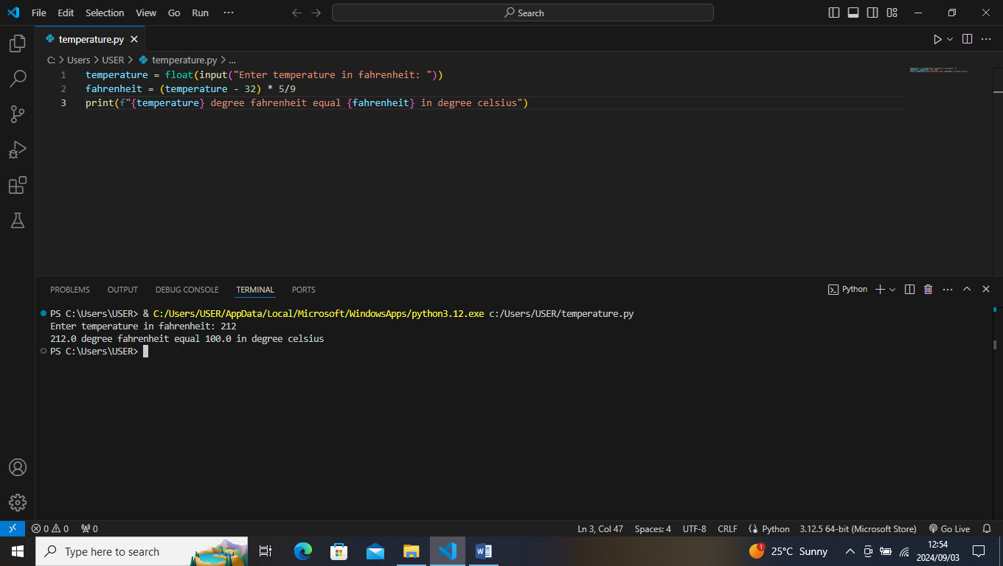

**Question 2**

Write a Java program that reads a number in inches, converts it to meters.    
Note: One inch is 0.0254 meter.  
Test Data  
Input a value for inch: 1000  
Expected Output:   
1000.0 inch is 25.4 meters

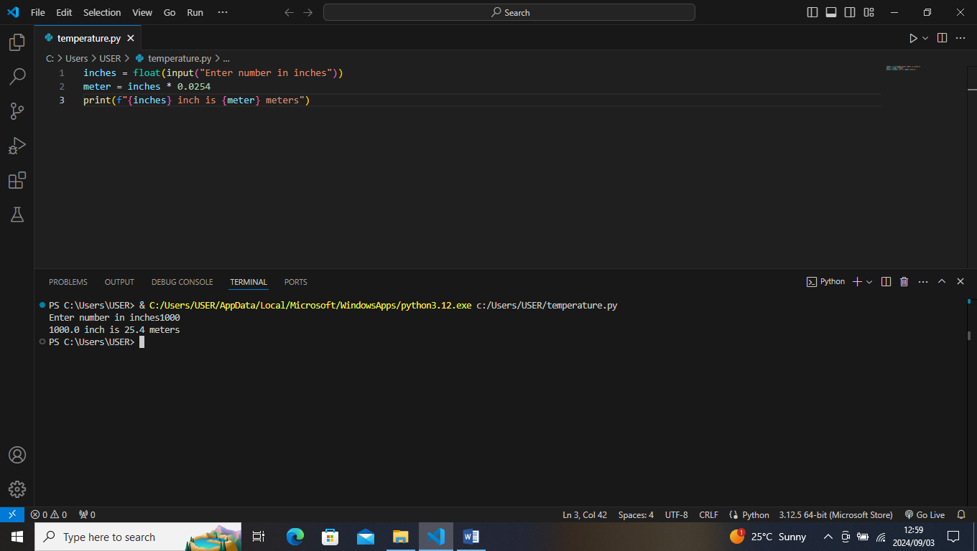

**Question 3**

Write a Java program that prints the current time in GMT.

Test Data  
Input the time zone offset to GMT: 256  
Expected Output:   
Current time is 23:40:24

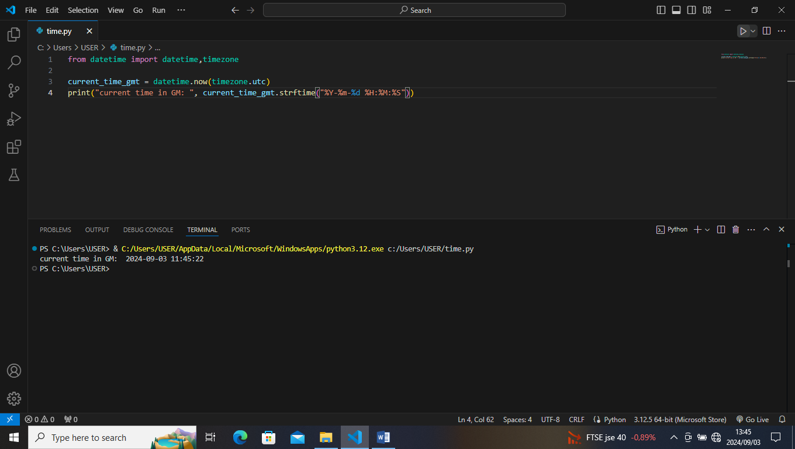

**Question 4**

Write a Java program to takes the user for a distance (in meters) and the time was taken (as three numbers: hours, minutes, seconds), and display the speed, in meters per second, kilometres per hour and miles per hour (hint: 1 mile = 1609 meters).

Test Data  
Input distance in meters: 2500   
Input hour: 5   
Input minutes: 56  
Input seconds: 23  
Expected Output:   
Your speed in meters/second is 0.11691531   
Your speed in km/h is 0.42089513   
Your speed in miles/h is 0.26158804

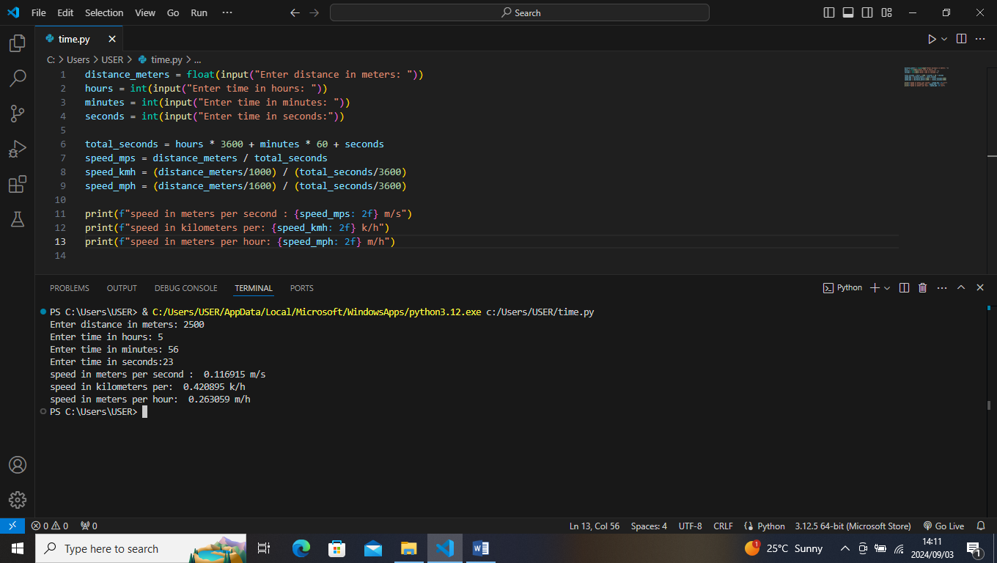

**Question 5**

Write a Java program to print 'Hello' on screen and then print your name on a separate line.    
Expected Output:   
Hello   
Alexandra Abramov

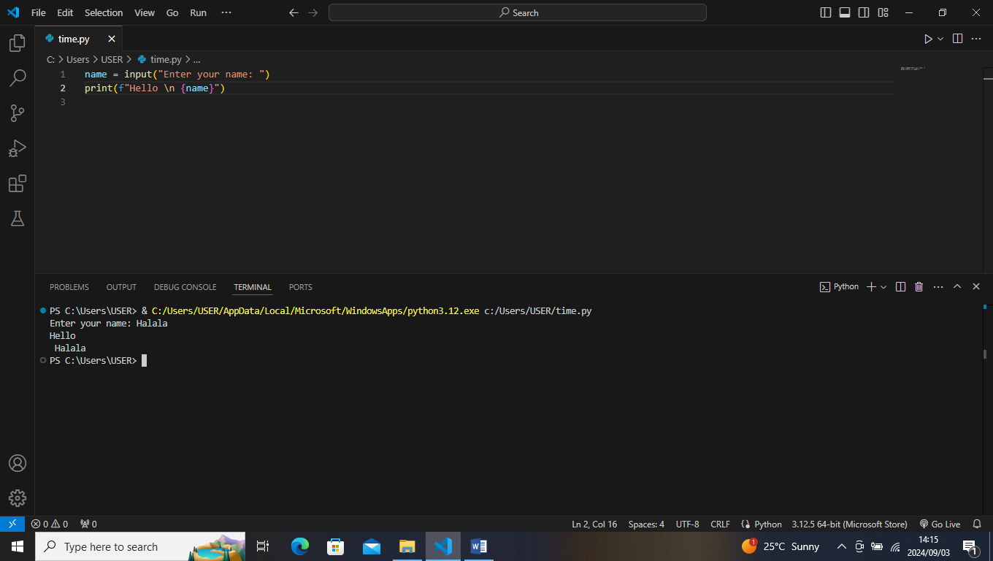

**Question 6**

Write a Java program to print the sum (addition), multiply, subtract, divide and remainder of two numbers.    
Test Data:   
Input first number: 125  
Input second number: 24

Expected Output:   
125 + 24 = 149  
125 - 24 = 101  
125 x 24 = 3000  
125 / 24 = 5  
125 mod 24 = 5

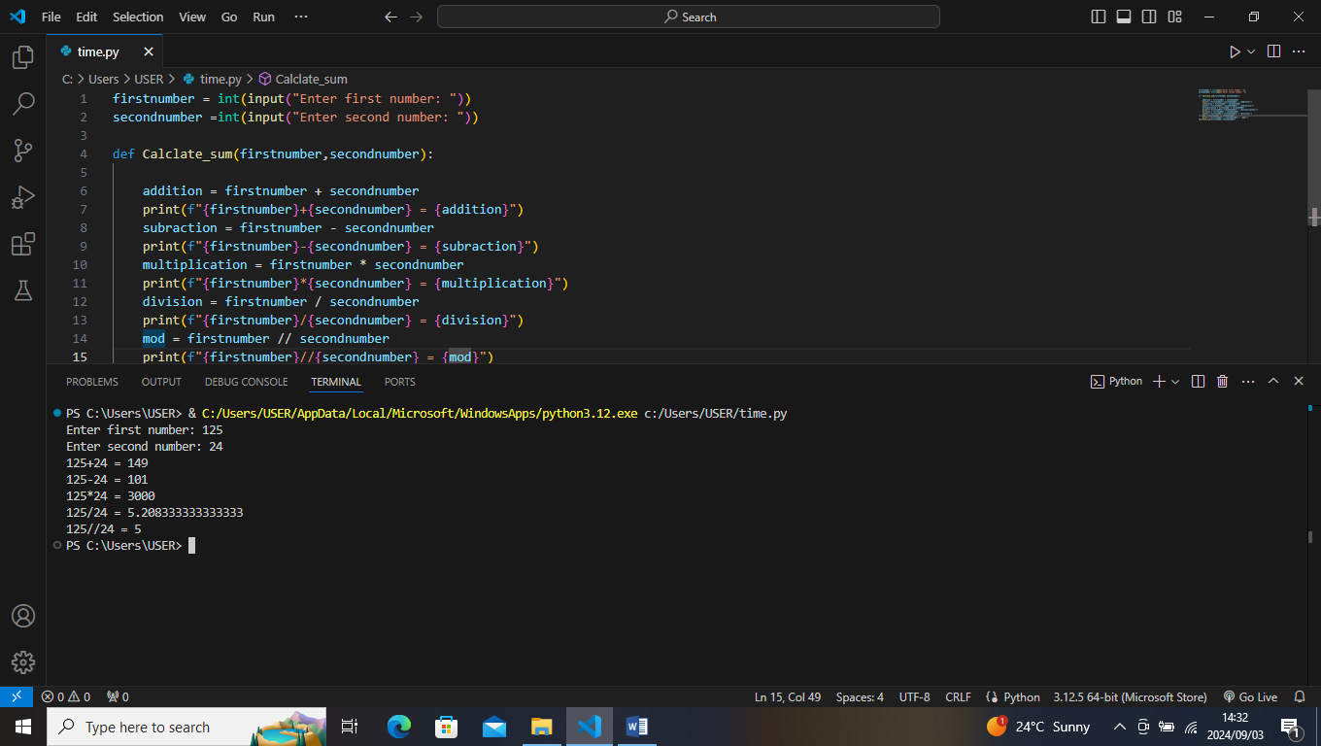

SECTION B: SUMMATIVE ASSESSMENT

Answer the following questions

**Question 1 (SO 2, AC 1, AC 2, AC 3, AC 4)**

You are required to assist a small business in your community to solve any of its business problems using a computer program.

1. Identify and describe the problem that the small business is facing. (4)
2. Interpret the problem facing the business and create a plan to develop a computer program solution. The plan must;
3. Propose a description of the problems to be solved by the development of the computer program.
4. Integrate the research of problems in terms of data and functions.
5. Include an evaluation of the viability of developing a computer program to solve the problem identified and compares the costs of developing the program with benefits to be obtained from the program.
6. Choose the best solution to the problem and must document the program features that will contain the capabilities and constraints to meet the defined problem. (15)

**INVOICE GENERATOR**

**Problem:** The company is facing inefficiencies and errors in their manual invoicing process leading to:

1. Manual entry errors
2. Inconsistent invoice formatting
3. Difficulty tracking payments and overdue invoices

The invoice method creates a formatted invoice that includes an invoice number, date, customer name , and purchased items with the total amount due.

**Program inputs and outputs:**

1. Customer information (name , address ,contact details)
2. Items
3. Payment information

**Program outputs:**

1. Invoice
2. Customer reports
3. Item report
4. Payment report

Integration of the research

**Data**:

* Customer information (name ,address ,contact details)
* Item data (descriptions, prices, quantities)
* Sales data (invoice dates, payment teams)
* Payment information(amount ,dates)
* Invoice data(invoice number, dates ,totals)

**Function:**

* generate invoices based on customer and sales data
* tracks payment and overdue invoices
* manage customer information and sales history
* ensure compliance with regulatory requirements and data security standards

**Capabilities and constraints:**

1. Automate invoicing processes
2. Reduces manual errors
3. Enhance customer satisfaction
4. Provide real- time insight and analytics

**Constraints:**

1. Requires accurate customer and sales data
2. Limited customization options for invoice templets
3. Dependent on reliable payment tracking data
4. Require regular software update for compliance and security

**Question 2 (SO 2, AC 1, AC 2, AC 3, AC 4)**

Using the plan that you developed in question 1 above, you are required to design a computer program. The computer program design must meet the following specifications;

* Incorporate development of appropriate documentation and is desk checked
* Include program structure components
* Include program logical flow components
* Include data structures and access method components

As evidence, you must save the program design on a disk and attach to your POE. (10)

The assessor/facilitator must complete the attached evaluation checklist.

**Question 3 (SO 3, AC 1, AC 2, AC 3, AC 4)**

You are now required to create a computer program that implements the design. Take note of the following;

* The creation must include coding from design documents.
* Names created in the program must describe the purpose of the items named.
* The creation includes conformance with design documentation.

As evidence, you must save the computer program on a disk and attach to your POE (15)

The assessor/facilitator must complete the attached evaluation checklist.

**Question 4 (SO 4, AC 1, AC 2, AC 3)**

1. Develop and attach a testing strategy. (6)
2. You are required to demonstrate how to test the computer program that you have developed in question 3 above. This must be done in the presence of the assessor/facilitator. (10)
3. Record the testing results. Attach the testing results in your POE. (6)

**Question 5 (SO 5, AC 1, AC 2, AC 3)**

You are required to implement the program inorder to meet the needs of the small business. Follow the guidelines below;

1. Explain how you shall check that the implementation complies with user expectations. (6)
2. Develop a plan for the installation process of the program. (5)
3. Develop a training plan for the small business owner and the users of the system. (8)

Invoicing program development

Automated invoicing system is a comprehensive invoicing program streamline the invoicing process, reduce errors and increase efficiency for small business.

Project features:

* Automated invoice generation
* Customizable invoice templets
* Payment tracking

Project benefits:

* Saves time and reduces manual errors
* Improves customer satisfaction and relationships
* Enhances financial management and reporting

How to use the program

* Step 1: setting up the program
* Step 2: creating a New Invoice
* Step 3: managing invoices

How to maintain the program:

* Deploy program to production environment
* Configure settings and customization options
* Conduct user manuals and guides

How to customize the program features:

* Understanding customization options
* Customizing invoice templets
* Configuring payment terms

**Question 6 (SO 6, AC 1, AC 2, AC 3, AC 4)**

Develop a documentation for the computer program. The documentation must;

1. Include annotation of the program with a description of the program purpose and design specifics
2. Include the layout of the program code including indentation and other acceptable industry standards
3. Include internal and external documentation with a level of detail that enables other programmers to analyse the program
4. Reflect the tested and implemented program, including changes made during testing of the program. (15)